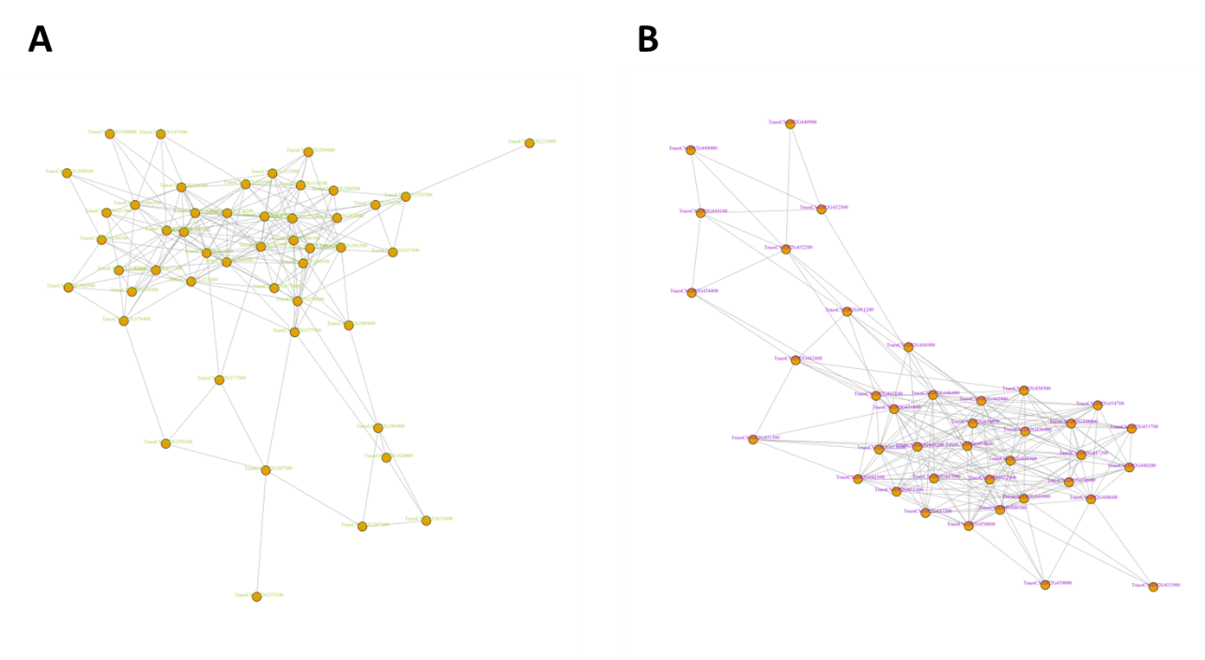
Figure S1 Weighted gene co-expression network analysis of DEGs in Pst-infected wheat young leaves and hub-gene analysis in greenyellow (A) and darkviolet module (B).

